Lab exam ai assisted coding -01  
  
1.write a comment prompt with 2-3 examples asking copilot/gemini to generate a python function that checks whether a string is a palindrome.  
  
Comment prompt--  
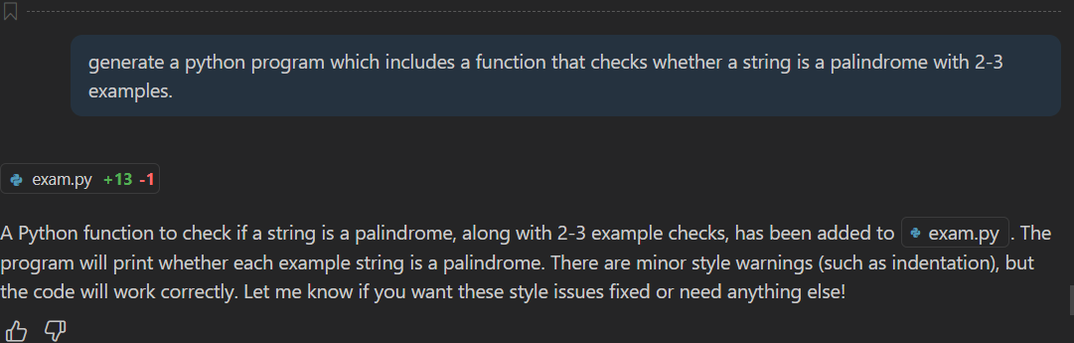

Code with comments-  
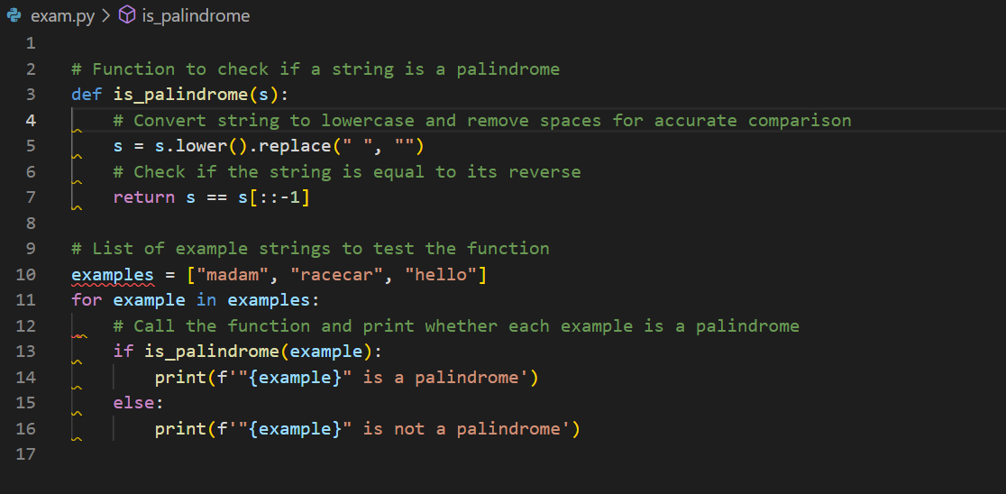

Output--  
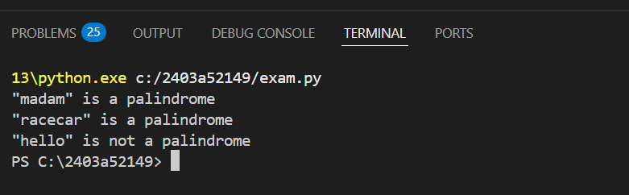

Explanation of the code--  
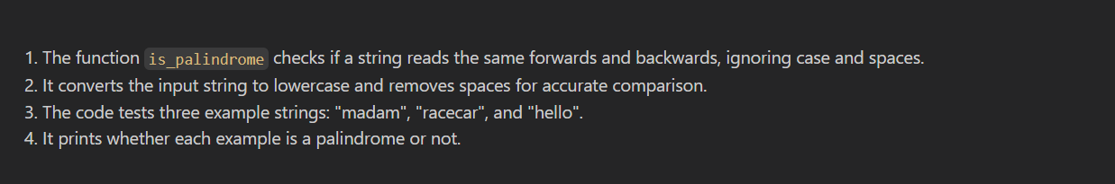

1. Ask google copliot/gemini to generate a python program that finds the largest and smallest numbers in a user-provided list.Then ,ask gemini to explain how the code works.

Comment prompt--

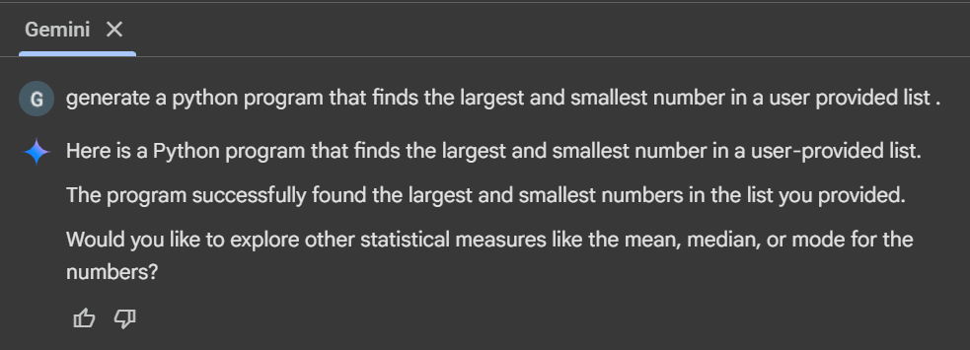

Code with comments-

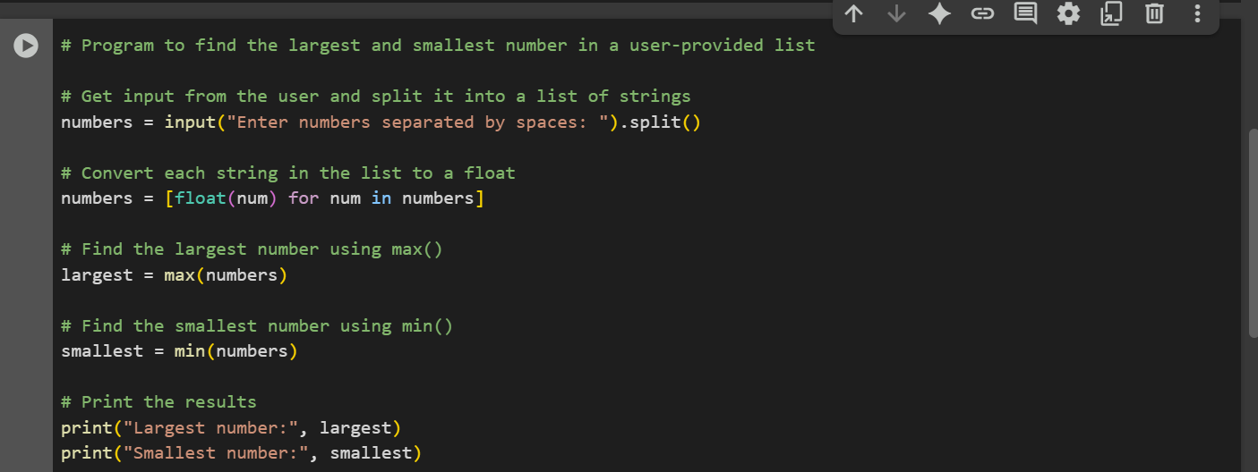

Output--

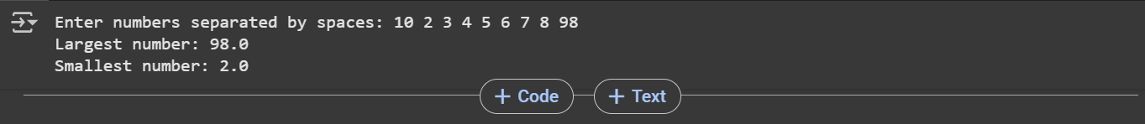

Explanation of the code--  
